**Station 1**

Aim: Determine the mass of the hanging object and the force applied to the ruler by the hinge at the retort stand.

Equipment: Retort stand, 2 boss heads, ruler on hinge, object of unknown mass, 10N or 20N spring balances, string 2 x 1m and 30cm rulers and scale.

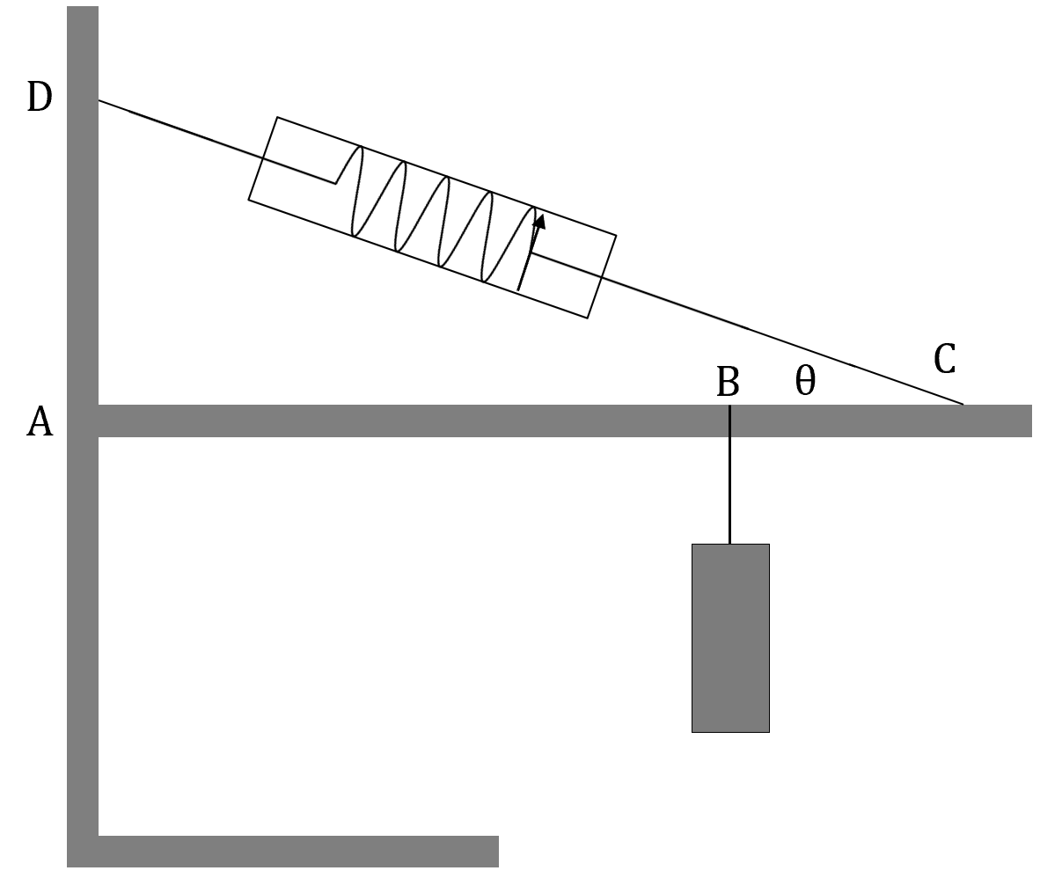

Q: Explain why it’s a good idea t face the retort stand as shown and not face the base in the opposite direction.

[2 marks]

Q: Draw in and label all the forces acting on the ruler.

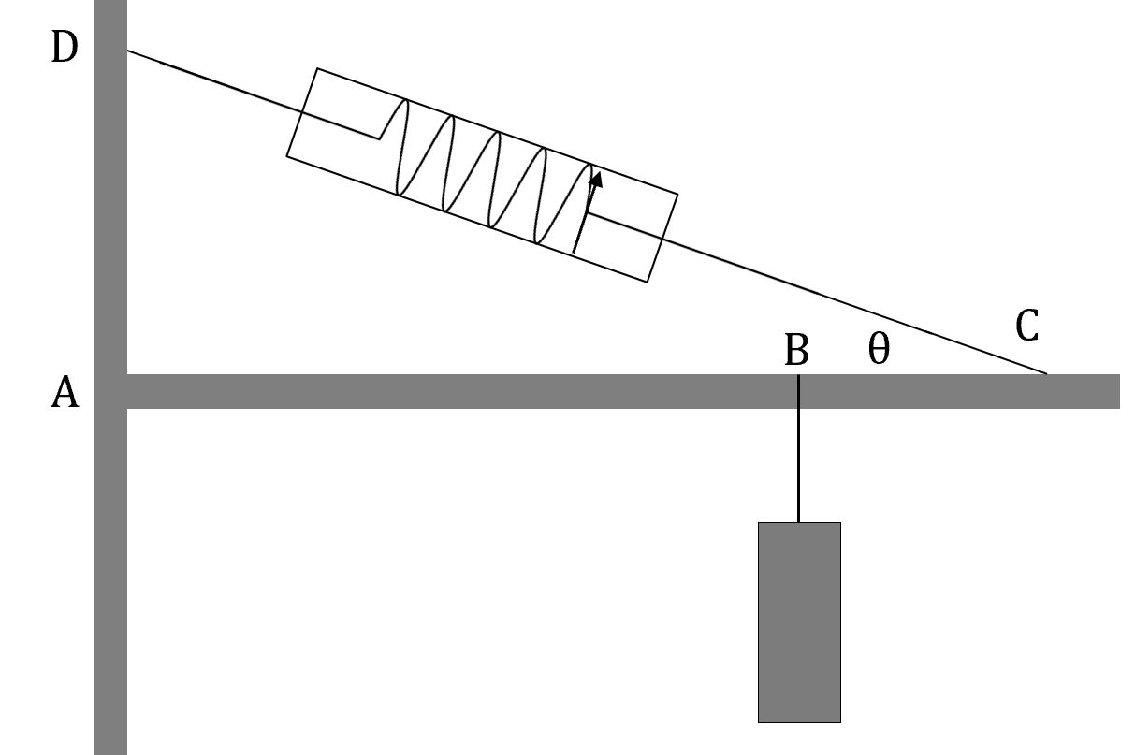

Q: To determine the mass of the hanging object, record the necessary measurements in the table below. Measure the mass of an identical ruler n the scale.

|  |  |  |  |  |  |  |
| --- | --- | --- | --- | --- | --- | --- |
|  | Distance AB(m) | Distance BC(m) | Distance AD(m) | Spring tension(N) | Ruler mass(g) | Ruler length(m) |
| Measurement |  |  |  |  | 106.2 |  |
| Uncertainty |  |  |  |  |  |  |

Q: Determine, by calculation, the angle the ruler forms with the string (θ).

[2 marks]

Q: Determine the vertical component of the tension in string DC.

[2 marks]

Q: Determine the mass of the object.

[4 marks]

Q: Determine;

[a] The horizontal force applied by the retort stand on the ruler.

[2 marks]

[b] The vertical force applied by the retort stand on the ruler.

[2 marks]

[c] The total force applied b the retort stand on the ruler.

[3 marks]

Q: Describe the errors in determining the mass.

[3 marks]

**Station 2**

Aim: Determine the centre of mass.

A new creature has been discovered in the deep recesses of the Amazon jungle. Scientists have named the creature “Morph” the stick insect. Of particular interest is the amazing way it can manoeuvre during flight. For research purposes, the centre of mass o Morph needs to be determined. A specimen is laid out on 2 scales (Morph’s backbone is a mere ruler).

Q: Draw and label on the diagram above all the forces acting on Morph.

[2 marks]

Q: Record all the necessary measurements required in a table.

[2 marks]

Q: Record where the centre of mass of Morph is.

[3 marks]